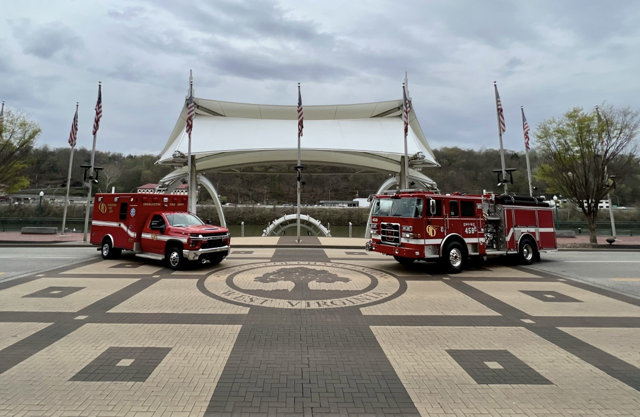  Charleston fire department  Firefighter recruit  Accepting Applications  June 13, 2022 –Aug. 15, 2022  Test: Aug. 15, 2022 6:30pm  Available at: CFD Administration Office 808 Virginia St. West or City Clerk’s Office at City Hall 501 Virginia St. East  The Charleston Fire Department is the largest fire department in the State of West Virginia with 169 uniformed personnel and 8 fire stations. Responsible for protecting a population of approximately 50,000 citizens within the City of Charleston, the Charleston Fire Department responds to 30,000 emergency incidents annually.  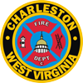 | Starting Pay:  EMT-B: $20.92/hour  EMT-A: $21.49/hour  Paramedic: $22.07/hour  *Dayshift  Average Annual Salary:  EMT-B: $52,000  EMT-A: $54,000  Paramedic: $57,000  * Based on wage scale, ambulance ride incentive, & holiday pay  Incentives:  Paramedic  $2,400 / Annually  $3.00 / Hour Ambulance Assignment  EMT - Advanced  $1,200 / Annually  $2.00 / Hour Ambulance Assignment  EMT – Basic  $1.00 / Hour Ambulance Assignment  $15,000 Sign-On Bonus  For Nationally Registered or  State of WV Certified Paramedics  College Incentive:  .50¢ per month for each credit hour up to 128 hours  “24 On - 48 Off” Schedule With Kelly Shift Every 8  Competitive Benefits Package  Written Test Incentive Points:  - Paramedic (20)  - Advanced EMT (15)  - Basic EMT (10)  - DOL Journeyman FF (10)  - Military Service* (5)  - Bachelor Degree (5)  - Associate Degree (2)  * Military Service WV Code § 6-13-1  For More info: 304-348-8137  www.charlestonfire.org

